**Friendship bracelets** – a suggestion for taking to events/activities to engage young people and give you a chance to discuss Girlguiding with them and their accompanying adults.

The QR code is linked to the Girlguiding Join Us site so volunteers and prospective members can join with ease.

**Instructions for Friendship Bracelets** *(There are also many useful tutorials online.)*

* Print off the templates onto thin card (these fit on to an A4 page.)
* Cut eight slits in the card circles and make a hole in the centre of the card.
* Cut seven lengths of wool, each 50cm long.
* Take your seven strands of wool and tie a knot at one end. Thread your strands through the hole in the disc, so the knot is underneath the disc with the strands on top.
* Take one strand at a time and slot it through one of the slits. You should have 7 strands tucked in, with one “space slot”.
* Take the 3rd strand to the LEFT of the spare slot, lift it up, bring it down and put across the spares slot. This creates a new space.

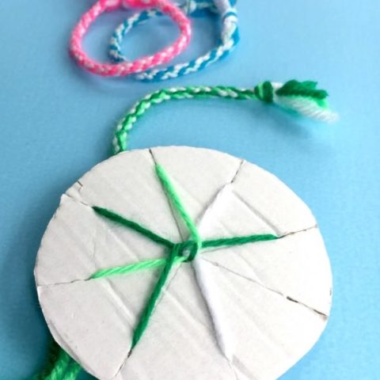

* Rotate your disc for this to point down and pick the strand 3 to the left and fold down.
* Repeat.
* The friendship bracelet will begin to “grow” on the other side of the disc, give it a gentle tug every so often.
* Once you are happy with the length, remove each piece of wool from their slots and pull them back through the loom.
* Knot (double knot if necessary) the end and tie the two ends together and there you have it….a Friendship Bracelet based on the Kumihimo technique.